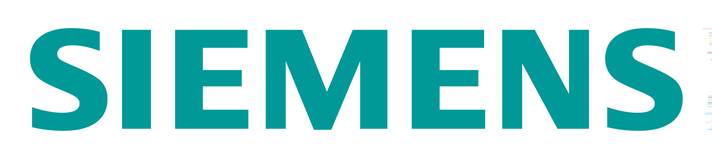 |  | F012 |  | 
NON CONFORMANCE REPORT ET

TEL: 0191 262 2266 : FAX: 0191 262 6622
E-MAIL: service@amecal.com & howard.oley@siemens.com
COMPLETED BY (NAME): |  |  |  |  | DATE:
APPLIES TO (NAME): |  |  |  |  | N/C REF No:
APPLIES TO (SITE): |  |  |  |  | Raised Against:
APPLIES TO (ASSET): |  |  |  |  | Siemens |  |  |  | AMECaL
CONTACT DETAILS:

REASON FOR DISCREPANCY (please enter “Yes” in one field)
LATE RETURN (# Days): |  |  | ASSET TRANSFERRED WITHOUT F011
INCORRECT DELIVERY: |  |  | INCORRECT / MISSING F011
FAULTY ASSETS: |  |  | NON-CONTACT / NO RESPONSE
DAMAGE ON RECEIPT |  |  | OTHER ISSUE:

COMMENTS / DETAILS OF NON CONFORMANCE
RECEIVED BY AMECaL |  | INITIAL: |  |  |  | DATE:
IMMEDIATE CORRECTIVE ACTION (AMECaL):

ACTIONED BY AMECaL |  | INITIAL: |  |  |  | DATE:
ADDITIONAL INVESTIGATION / PREVENTATIVE MEASURES / COMMENTS (AMECaL):

CLOSED BY AMECaL |  | INITIAL: |  |  |  | DATE:

